Grade 9: BUSINESS ACTIVITIES
QUESTION 1: PRICE THEORY
1.1 Look at the following picture and answer the questions that follow.
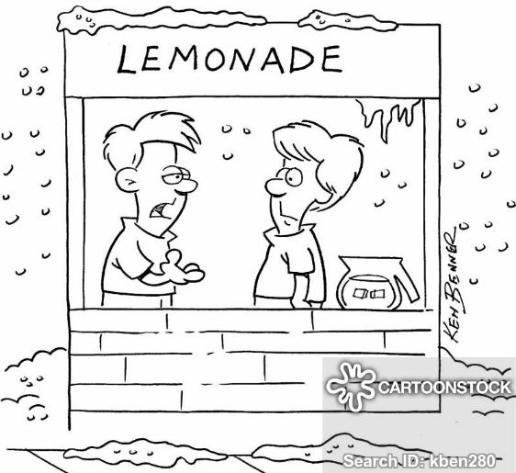
1.1.1 | Looking at the illustration above, indicate whether the demand for lemonade is high or low. Motivate your answer. | (1)
1.1.2 | Explain ONE factor that can influence the demand for lemonade, DO NOT use weather as a factor. | (2)
The following table represents the supply and demand schedule for Leo’s lemonade.
Price per lemonade | Quantity demanded | Quantity supplied
R2 | 100 | 20
R4 | 80 | 40
R6 | 60 | 60
R8 | 20 | 80

1.2.1 | Use the above schedule to draw a demand and supply curve on the same axes and indicate the equilibrium point. | (6)
1.2.2 | How much is the equilibrium price? | (1)
1.2.3 | Define the Law of Demand. | (2)
QUESTION 2 SECTORS IN THE ECONOMY
2.1 Look at the following pictures and answer the questions that follow.
PICTURE A | PICTURE B | PICTURE C
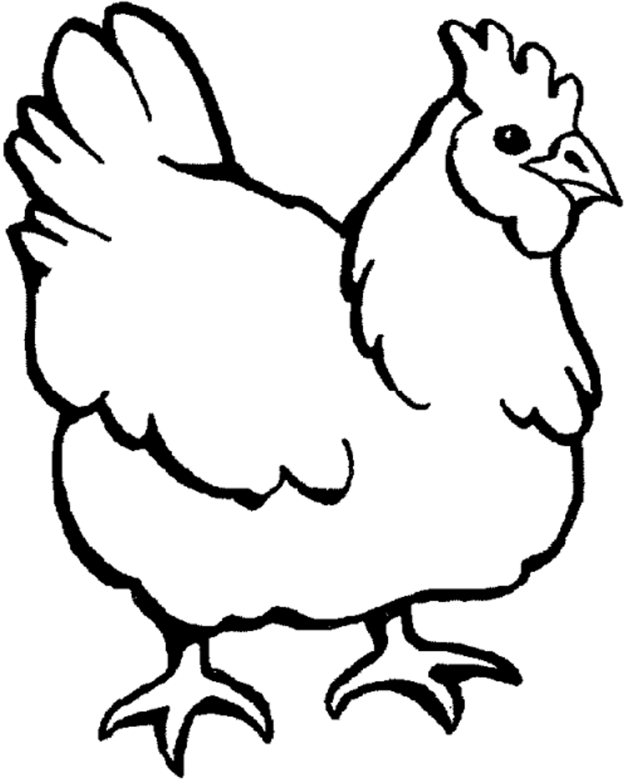 | 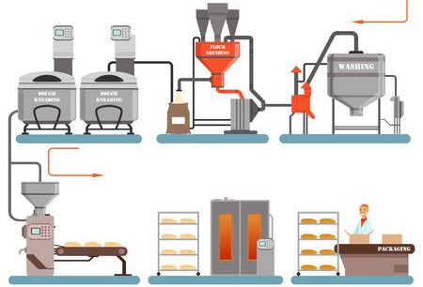

2.1.1 | Identify the sectors represented in picture A – C above. | (3)
2.1.2 | Mention TWO examples of businesses for picture A and C. DO NOT use the picture as an example. | (4)
2.2 | Discuss the interrelationship between the three sectors. | (3)
(10)

Question 3: Demand and Supply
Example
Question: Why do people buy more grapes in December than in July?
Answer: People buy more grapes in December than in July because grapes are a summer fruit. More farmers sell their grapes in summer. The supply is high and the prices are lower because the demand is satisfied easily

3.1 Why are oranges more expensive in December than in July? (2)
3.2 Why is holiday accommodation more expensive during peak holiday seasons? (2)
3.3 Why do clothing stores have sales at the end of the winter and summer seasons?(2)

3.4 Write your answers in table format. (9)
 | Demand | Supply | Price
Example: Grapes in December | High | High | Low
1. Oranges in December
2. Holiday accommodation during peak holiday season
3. Clothing sales at the end of winter and summer seasons

